**Azure Content Delivery Network**

Caching is one of the ways for performance improvement. Windows Azure uses caching to increase the speed of cloud services. Content Delivery Network (CDN) puts stuff like blobs and other static content in a cache. The process involves placing the data at strategically chosen locations and caching it. As a result, it provides maximum bandwidth for its delivery to users. Let’s assume an application’s source is far away from the end user and many tours are taken over the internet to fetch data; the CDN offers a very competent solution to improve performance in this case. Additionally, it scales the instant high load in a very efficient manner.

Azure CDN caches web content at a strategically placed location to provide maximum throughput for delivering content to users. For example,

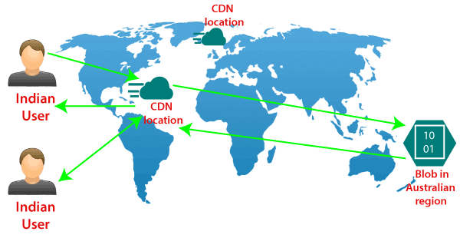

We have a vast amount of video content located in Australia, but the primary users of that content are located in the US, and if any of the users from India will try to access the content from Australia. Then they will experience some latency because of the distance between Australia and India. In that scenario, we can use a content delivery network to reduce that latency.

**CDN products**

There are several types of products that are available by Azure, and there are two other third party providers that provide CDN products in partnership with Microsoft.

* Azure CDN Standard from Microsoft (Preview)
* Azure CDN Standard from Akamai
* Azure CDN Standard from Verizon
* Azure CDN Premium from Verizon

**Features of Content Delivery Network (CDN)**

Following are the fundamental features of Azure CDN**:**

**Dynamic site acceleration**: It is the capability to deliver dynamic web content with minimum latency. It is achieved by using different techniques such as route optimization to avoid congestion points, TCP optimization, etc.

**HTTPS support**: It provides us the HTTPS support of secure web content.

**Query string caching:** Based on query string caching, we can cache the content also within CDN location.

**Geo-Filtering:** We can apply some geo-filtering if we want certain content filtered for a particular geographical region.

**Azure diagnostics logs**: It provides the facility of records of diagnosis.

**CDN configuration**

When we start using CDN, the first thing we will create is the CDN profile. It is a collection of CDN endpoints, and by default, it can contain up to 10 CDN endpoints. When we are creating a CDN profile, we will specify the type of product that you want to use. For Example, CDN premium from Verizon or CDN standard for Microsoft, etc.

Secondly, we will create a CDN endpoint. When we are creating CDN endpoint, we will specify the name, and also origin type what exactly we’re trying to configure this CDN for. It can be Azure storage, cloud storage, web app, or a custom origin.

Finally, we will define the Origin path where these videos or web content is located and also the protocol of origin. Once we create a CDN endpoint, we’ll get an endpoint that will be whatever the name we have given? example.net.

**How to use Azure CDN?**

When a user requests data from a website, the DNS sends this request the appropriate POP, which is usually the one that is geographically closest to the user. If the requested data is not present in a server on the POP, the server requests the data from the origin server. The origin can be a resource in Azure. The data is sent to the server in the request location and is cached there and returned. The user will then get this cached data.

The advantage of caching this data is that any number of users who request the same kind of data from then will get a cached copy of the data until its life cycle in the POP server is over. This makes for the efficient delivery of content to the users.

Caching is done on static content only but Azure CDN can also deliver dynamic content at high speeds through dynamic site acceleration.

When an endpoint is created in Azure content delivery network, it can be optimized for the following depending on the provider:

* General web delivery
* General media streaming
* Video-on-demand media streaming
* Large file download
* Dynamic site acceleration

**Ways to control how files are cached**

Caching rules

Global caching rules

Custom caching rules

Purged cached assets

Pre-load assets on an Azure CDN endpoint

**Why use Azure CDN?**

A large percentage of web traffic is static content such as images, text, videos, etc. So, delivering content for all requests coming into the origin server will be hectic for the server. Instead, if the content is cached in locations near the users, the load on the origin server can be transferred to these globally-located POPs. This reduces the need of having to keep powerful and costly infrastructure for the origin server.

**Advantages of Azure CDN**

The main advantages of using Azure CDN are:

* High performance in delivering web content
* No need to spend high amounts for setting up infrastructure
* Easy configuration and maintenance
* Decrease load on the main server and offload it to the edge servers

**Disadvantages of Azure CDN**

The disadvantages are of using Azure CDN are:

* The edge servers in a CDN can become points of failures, which can cause the web content from not being delivered
* Caching and replicating sensitive data might prove to be unwanted

**Azure CDN Pricing**

Azure CDN is available in Standard Microsoft, Standard Verizon, and Standard Akamai in India.

|  |  |  |  |  |  |
| --- | --- | --- | --- | --- | --- |
| **Outbound Data Transfers** | **Zone 1** | **Zone 2** | **Zone 3** | **Zone 4** | **Zone 5** |
| First 10 TB/Month | **₹5.8357** per GB | **₹9.2939** per GB | **₹16.7866** per GB | **₹9.3659** per GB | **₹11.3832** per GB |
| Next 40 TB (10–50 TB/Month) | **₹5.4034** per GB | **₹8.7175** per GB | **₹13.4005** per GB | **₹9.0778** per GB | **₹8.7175** per GB |
| Next 100 TB (50–150 TB/Month) | **₹4.0346** per GB | **₹8.0691** per GB | **₹12.1037** per GB | **₹8.0691** per GB | **₹7.3487** per GB |
| Next 350 TB (150–500 TB/Month) | **₹2.6657** per GB | **₹6.7003** per GB | **₹10.7348** per GB | **₹6.7003** per GB | **₹6.7003** per GB |

The pricing given here is for Standard Microsoft, Standard Verizon, and Standard Akamai. For data transfers above the specified limits, you need to contact Microsoft Azure Sales for pricing details.

Other pricing plans depending on the provider are also present for which you can refer to Azure CDN pricing.